Before User Testing

Initial Wireframe changes  
1. The only Change I made was to the Calendar Page, the page was a bit cluttered, so I decided to change it into two different pages. The First Page was the top half (the calendar), the second page, was the Weekly Assignments.

Initial Design

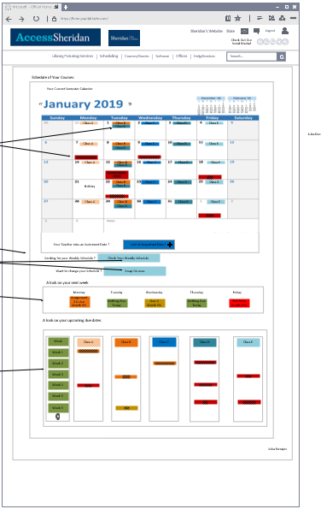

Changed to

1.Monthly Schedule

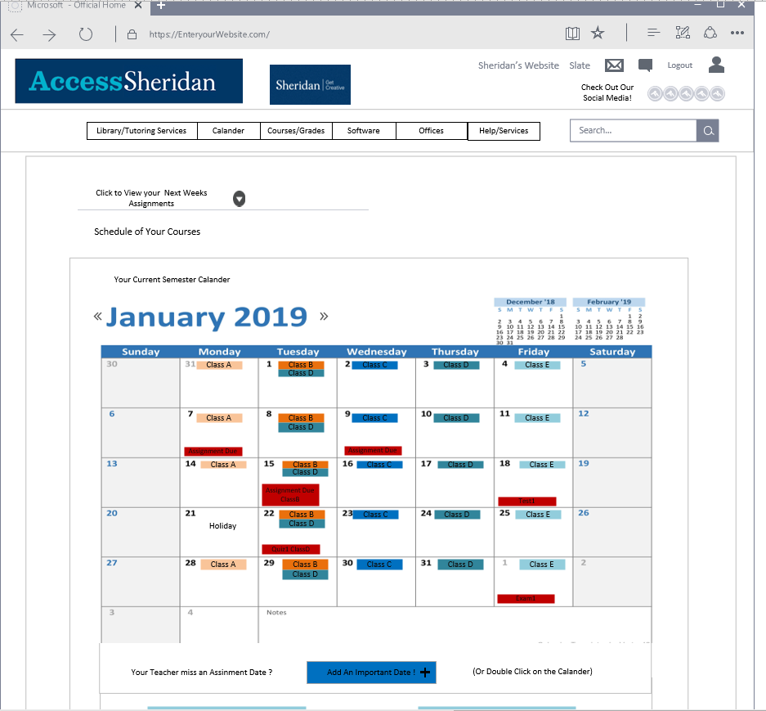

Changed Design

2. Weekly Assignments

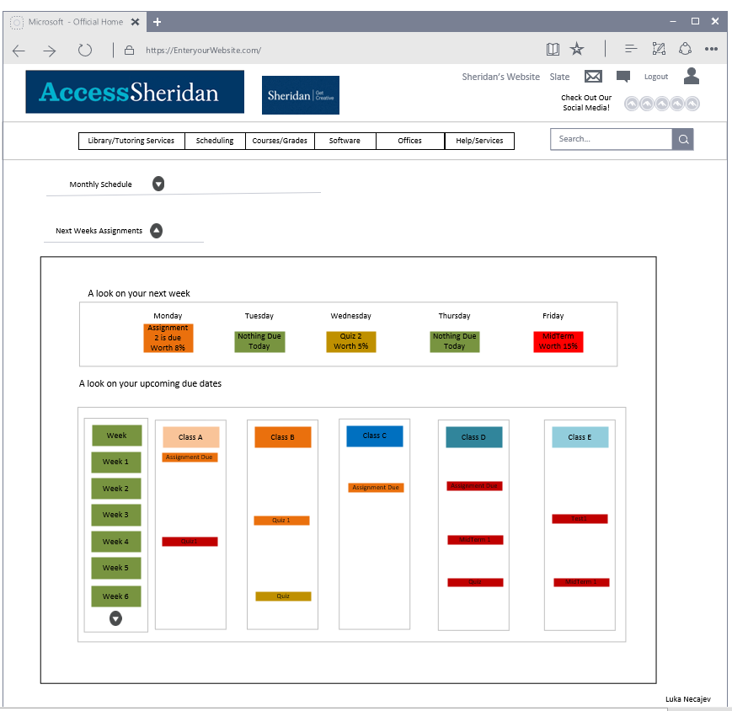

USER TEST 1  
change Facilitator: Luka Necajev

The One Item that I decided to change in the design was the big problem that I had not thought about, was the ability for people to find where the Weekly assignments, instead of it being all one page on the calendar, I separated that same page and allowed a dropdown feature. This addition made it so it was hard to find weekly assignments. So I added it in the calendar dropdown. Then tested to see if they enjoyed the redesign

Initial Design

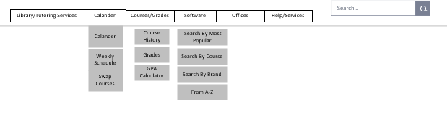

Changed Design

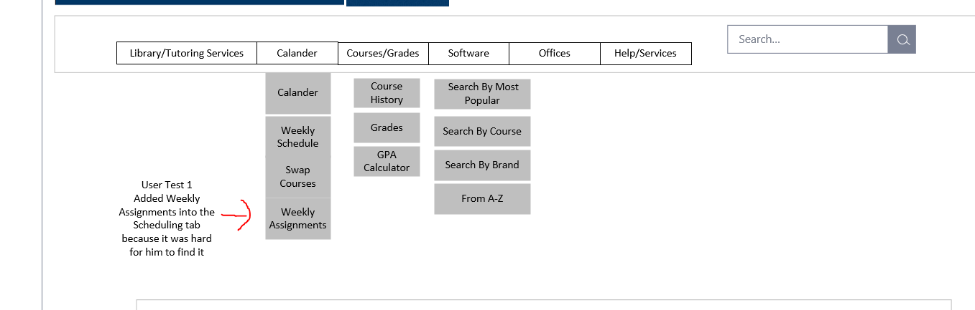

USER TEST 2

Change Facilitator: Luka Necajev

The Major change that was a re occurring problem that the users initially thought that the Swap courses, should be under Courses, and not under calendar. So I fixed it by moving it to courses/grades (later named courses) Then tested to see if they enjoyed the redesign

Initial Design

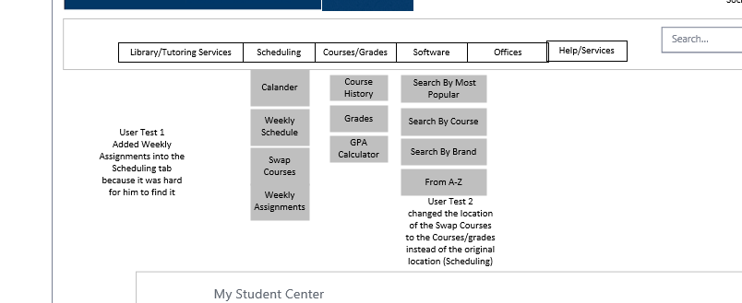

Changed Design

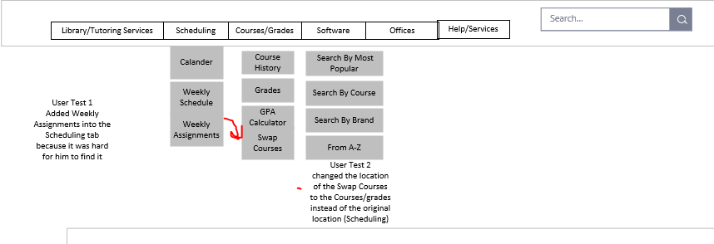

USER TEST 3

Change Facilitator: Luka

Changed the I added the swapping courses to the course/grades page because it was listed in the navigation bar but not in the courses/grades page, so I added the item to above the calendar to make sure that even if you click on the link, it will still take you to the swap courses page. Then tested to see if they enjoyed the redesign

Initial Design

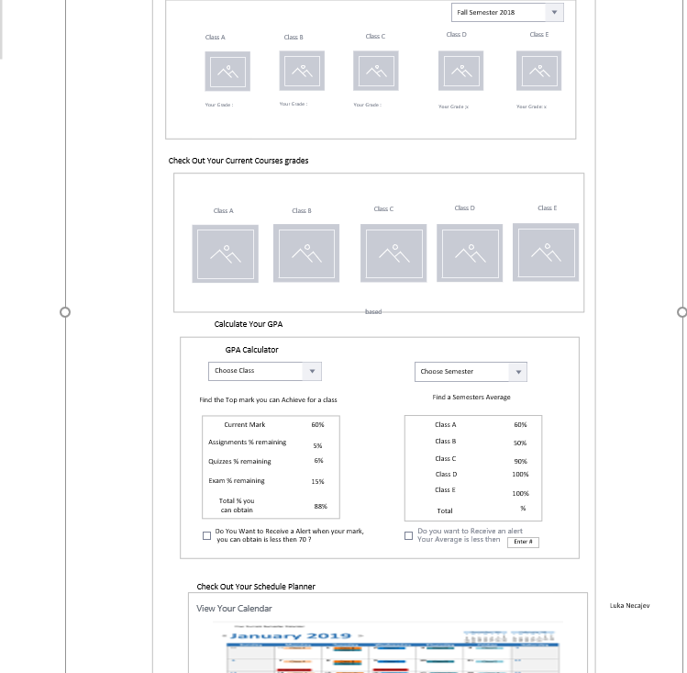

Changed Design

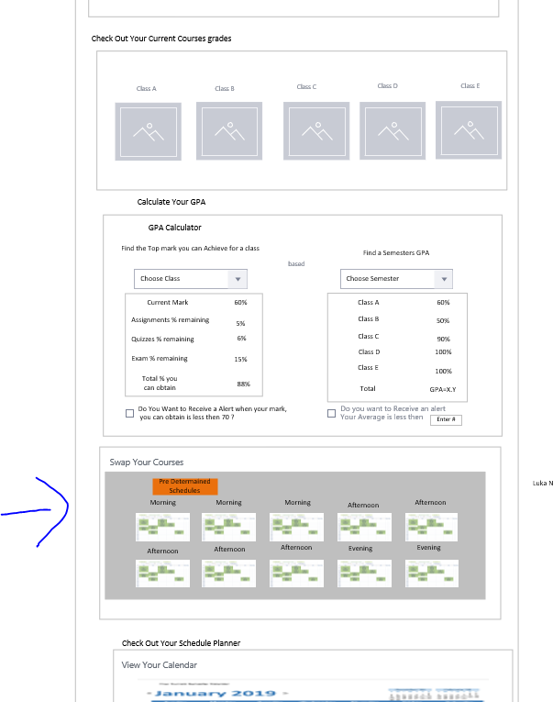

USER TEST 4

For this test they did not state anything that was very important so I just changed the label for courses and grades, to just courses because this is the second user test that stated that this label should be changed, I placed it as courses because it would make sense to swap courses and find your grades in your courses, but not to be able to swap courses in your grades nav.

I also changed the label for calendar because 2/3 people said that it should be changed to calendar instead of Schedule.  
Then tested to see if they enjoyed the redesign

Initial design

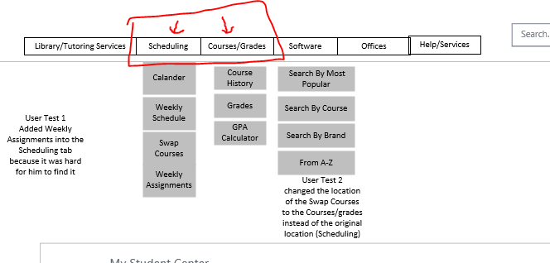

Changed design

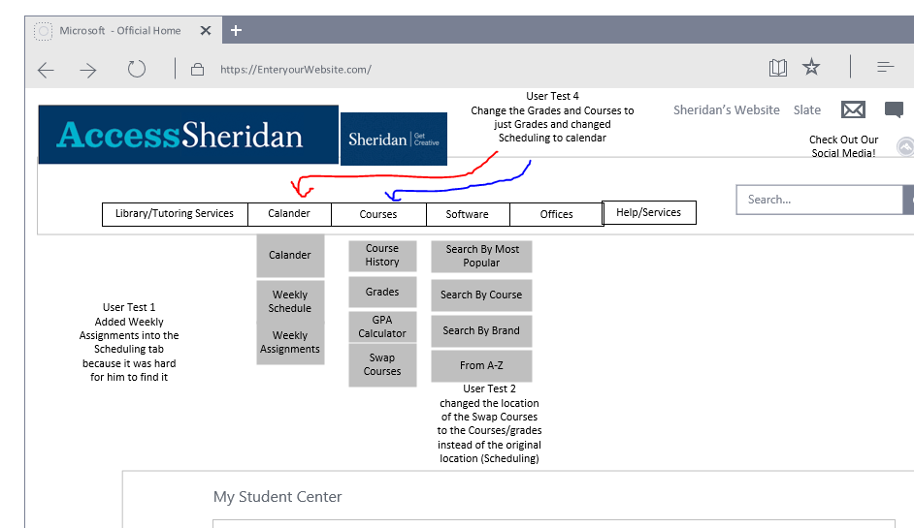

USER TEST 5

I changed the GPA calculator to make it work automatically and make calculations without the users entry of any information. I also added an icon for help and when clicked it would give a information and a legend with instructions on how to use the application. I then swapped so that you see the title before the cchoice of semester or class, and then added a extra field so it showed you your GPA and your grade, so then you can

Initial design

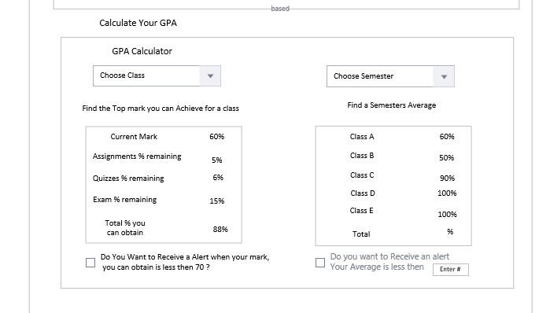

Changed design

